

**Fintech Project - TEAM 1**

**Date: 03/21/20**

**Prof. Michael Rolleigh**

**Authors: Nassiri Bamba, Fabiola Puello, Wai Hoi Li, Nishil Patel, Guglielmo Villani**

Table of Contents

Our Strategy 2

Portfolio Analysis 3

Risk Parity 3

Sharpe Ratio 3

Treynor Ratio 4

Volatility 4

How we compute our analysis 4

*Portfolio Analysis* 4

*Technical Analysis* 5

Funds & Sectors - Appendix 1 5

Risk Parity - Appendix 2 6

Sharpe Ratio - Appendix 3 6

Treynor Ratio - Appendix 4 7

Minimum Volatility - Appendix 5 8

Technical Analysis Results - Appendix 6 8

# 

# **Our Strategy**

The objective of our project is to prove the inclusion of commodities in a portfolio serves to hedge against inflation, protecting the purchasing power of the investor. We decided to focus on the commodity market because they are ancient trading assets which are necessary for human existence and are also utilize for economic development. These characteristics guarantee that they’re going to exist forever (majority if not all). Our strategy was to select 7 sectors from the commodity market and identify the 4 top ETFs/ETNs of each sector based on Total Net Assets. Once the 28 funds were identified, we downloaded the maximum available monthly historical prices from Yahoo Finance and proceeded to clean the data based on common dates. As result, the time frame for our analysis ended up being from 04/01/2012 to 02/01/2020 (approx. 8 years). Once we had the data cleaned, we proceeded to create an equally weighted portfolio which would be subsequently optimized to analyse the data (see Appendix 1).

The portfolio contains seven different funds, which are energy, farm, general agriculture, precious metals, industrial metals and gold. All funds are targeting the US market, except for general agriculture, which contains worldwide ETFs. Furthermore, gold is separated from precious metals due to its unique characteristics of having a high volatility and being a traditional safe haven.

# **Portfolio Analysis**

## Risk Parity

General agriculture has lower risk and higher weight contribution to the equal risk portfolio, while all other funds are almost equally distributed (see Appendix 2). It is because the coronavirus pandemic and locust swarm situation were not that severed yet back when the portfolio was being formed and analysed. Therefore, the proportions of gold, farm, and general agriculture funds are not being affected.

## Sharpe Ratio

We performed the Sharpe ratio on python using the 30 years treasury yield as our risk-free rate. By maximizing the Sharpe ratio, we wanted to know which fund performed better during 2012-2020. Based on our analysis, the Farm fund received a 100 % weight because from 2012 to 2020, the farm fund generated better returns than the other funds (see Appendix 3).

## Treynor Ratio

We wanted to know how much excess return was generated for each unit of risk taken on by a portfolio, that’s why we maximized the Treynor ratio on python. Just like the Sharpe ratio, the Treynor analysis also allocated 100% weight to the Farm Fund. Once again, it proves that the farm fund was more profitable than the others during the same period (see Appendix 4).

## Volatility

We minimize the volatility on python to determine which funds are more volatile than the others. The result showed that the general Agro-fund is the least volatile, with 81%. The following least volatile is the precious metal with 16%. The most volatile funds are the gold and the energy funds because they are the most traded funds in the commodity market (see Appendix 5).

# **How we compute our analysis**

## *Portfolio Analysis*

Our Portfolio Analysis which included 4 different optimizations and 3 linear regressions, was done entirely with *python* on a Jupyter Notebook. The first task was to get the relevant data and clean it. This we did on Excel as it required some editing and formatting which was easier and simpler to do on Excel. We then imported this data to *python* and used it for all further purposes. The *python* modules we used were - pandas, numpy, scipy, and statsmodels. We started by creating portfolios with random weights and storing their Standard Deviation and Return. This was all looped and the number of simulations to be run were set to 25,000.

The next part was the optimizations. Since the *python* optimizer only allows ‘minimization’, we calculated the Negative Sharpe & Treynor Ratios so that we could then get our portfolios with maximum Sharpe & Treynor. The minimum volatility optimization was much simpler as we already had the portfolio volatility. The 4th optimization was an Equal Risk-weighted Portfolio. This is a common variation on Risk Parity which assigns weights to assets such that they have equal risk contribution to the total portfolio volatility. Furthermore, we used the ‘*models*’ directory of ‘*statsmodels*’ to run our linear regressions. Our first analysis was a regression between the Equally Weighted Portfolio of our 7 funds (EWP) and a commodity Benchmark (GSCI Commodity Index). The next analysis was a Multifactor Regression between the EWP and 4 factors (Fed Rate, Inflation Index, USD Price Index, and the Risk-free Rate). This analysis was done to look at the effect of movements in these Macro-economic factors on our EWP. Based on this analysis, we performed our third regression, now between the EWP and just the US Dollar Index. The result reflected what we were expecting, which was that there would be a high negative *beta*.

## *Technical Analysis*

Finally, we also did a Technical Analysis of our 7 sectors to get a better idea about what to expect in the coming months and give our opinion on whether it’s a BUY or a SELL call for that sector. The indicators we looked at were – RSI(14), STOCH, Williams %R, Ultimate Oscillator, and MACD(12,26). We also look at the Simple and Exponential ‘Moving Averages’ for 5, 10, 20, 50, 100, and 200 days. Our Technical Analysis showed that due to current market conditions, all the sectors were a SELL call except Gold and Precious Metals which had a BUY call (Appendix 6).

**N.B. The *python* code can be found here:** [**https://github.com/NishilP/Fintech-Project**](https://github.com/NishilP/Fintech-Project)**).**

# *Funds & Sectors - Appendix 1*

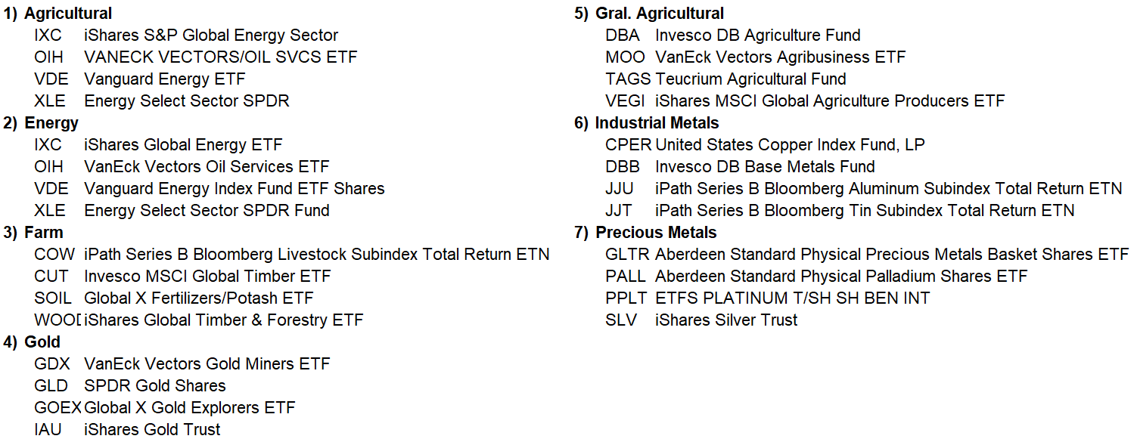

# *Risk Parity - Appendix 2*

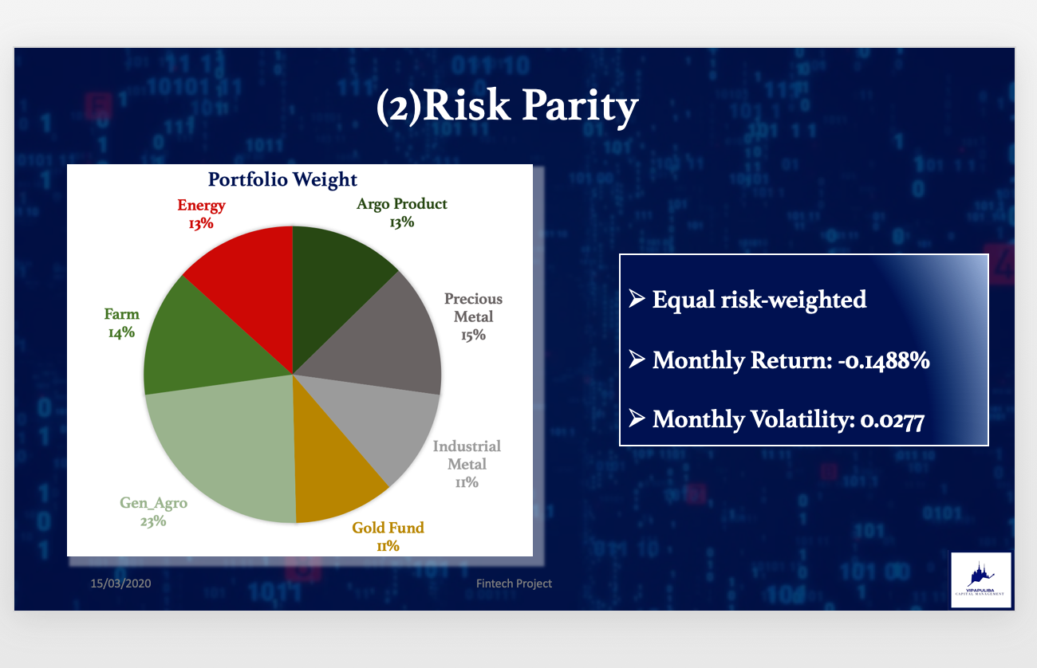

# *Sharpe Ratio - Appendix 3*

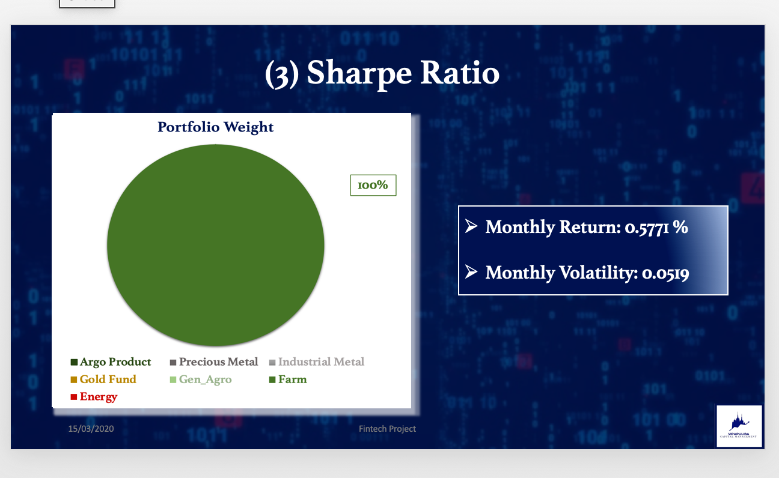

# *Treynor Ratio - Appendix 4*

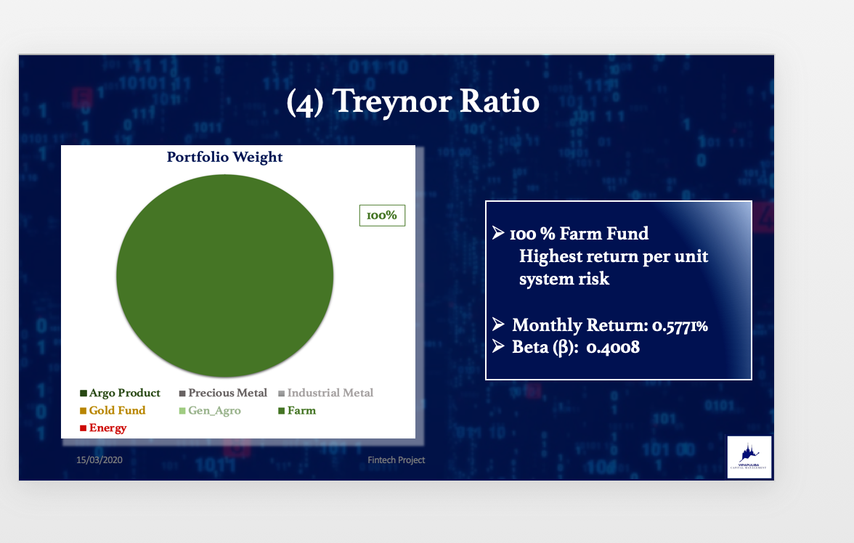

# *Minimum Volatility - Appendix 5*

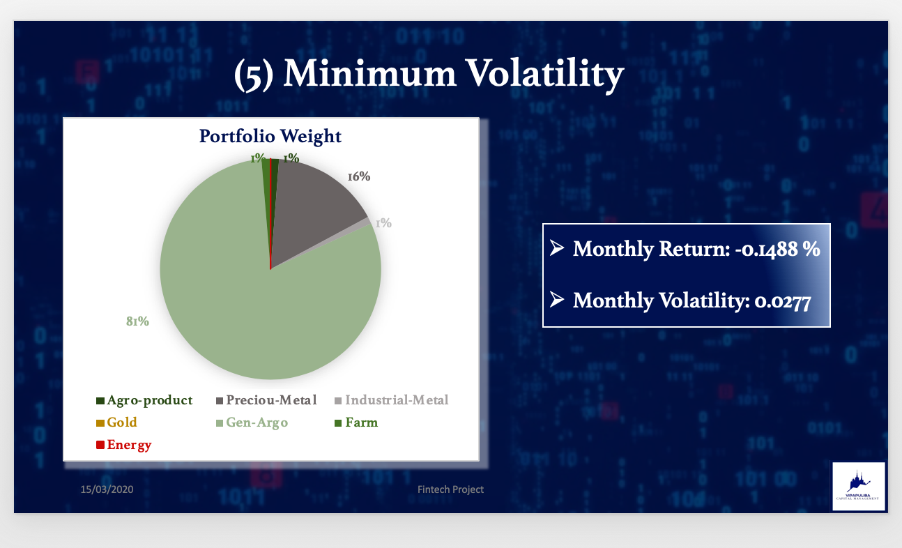

# *Technical Analysis Results - Appendix 6*

